1. Team members and their roles
   1. Patrick Brannen - Database side (Back End)
   2. Ryan Tanner - GUI Side (Front End)
2. Team Chair
   1. Patrick Brannen
3. List of Functionality
   1. From user input it will be able to generate the ABET forms with the appropriate data calculated
   2. The software will be able to take JSON inputs from the UI, representing the number of students in a class that meet each category on the form, and calculate the statistics to create the final form.
   3. The user will be able to select which form type which the system will use to generate the correct form. So the system will take JSON including the form type to create an ABET form.
   4. An administrator will be able to create a PDF containing the percentages of students that meet given outcomes
   5. An instructor will be able to generate and edit the forms for each of his/her classes.
   6. The system will keep track of which courses
4. Results of tests for a functional item
   1. Our initial functional item involves generating the input form for professors. The entirety of the HTML for the page is generated using JavaScript. No styling has been added so the result looks a little bland, for now. Some changes need to be made to fit the formatting addressed our last meeting.
   2. Result:

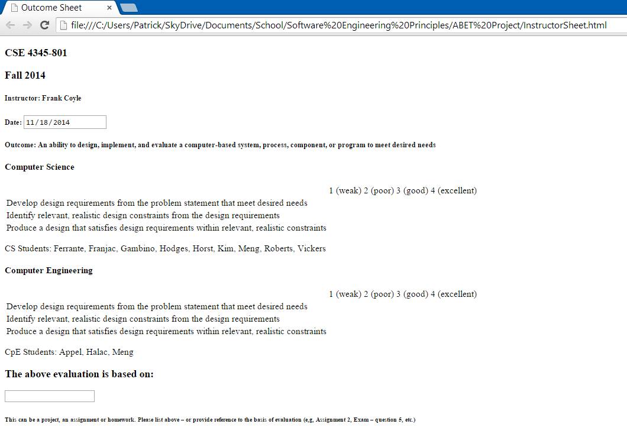

* 1. The Code:

$( document ).ready(function() {

var headerDiv = getHeaderDiv(TEMP_COURSE, TEMP_SEMESTER, TEMP_INSTRUCTOR, TEMP_OUTCOME);

document.body.appendChild(headerDiv);

var i = 0;

for(var major in majors.major){

var tableDiv = getTableDiv(majors.major[major], TEMP_OUTCOME, TEMP_STUDENTS.students[i++]);

document.body.appendChild(tableDiv);

}

var basisDiv = getBasisDiv();

document.body.appendChild(basisDiv);

});

var getHeaderDiv = function(course, semester, instructor, outcome) {

//initialize variables

var header = document.createElement("div");

var courseElement = document.createElement("h3");

var semesterElement = document.createElement("h3");

var instructorElement = document.createElement("h5");

var dateElement = document.createElement("h5");

var dateInput = document.createElement("INPUT");

var todaysDate = getTodaysDate();

var outcomeElement = document.createElement("h5");

//set contents

courseElement.innerHTML = course;

semesterElement.innerHTML = semester;

instructorElement.innerHTML = "Instructor: " + instructor;

dateElement.innerHTML = "Date: ";

dateInput.setAttribute("type", "date");

dateInput.setAttribute("value", todaysDate);

outcomeElement.innerHTML = "Outcome: " + outcome.description;

//append to DOM

dateElement.appendChild(dateInput);

header.appendChild(courseElement);

header.appendChild(semesterElement);

header.appendChild(instructorElement);

header.appendChild(dateElement);

header.appendChild(outcomeElement);

return header;

}

var getTableDiv = function(major, outcome, students) {

//initialize variables

var tableDiv = document.createElement("div");

var description = document.createElement("h4");

var table = getTable(outcome.PerformanceCriteria);

var studentList = getStudentListElement(students);

description.innerHTML = major;

//append to DOM

tableDiv.appendChild(description);

tableDiv.appendChild(table);

tableDiv.appendChild(studentList);

return tableDiv;

}

var getTable = function(criteria) {

var table = document.createElement("table");

table.appendChild(getTableHeader());

for(var i = 0; i < criteria.length; i++) {

var row = document.createElement("tr");

var cell = document.createElement("td");

cell.innerHTML = criteria[i];

row.appendChild(cell);

for(var j = 0; j < 4; j++) {

cell - document.createElement("td");

row.appendChild(cell);

}

table.appendChild(row);

}

return table;

}

var getTableHeader = function() {

var row = document.createElement("tr");

var data = document.createElement("td");

row.appendChild(data);

var data = document.createElement("td");

data.appendChild(document.createTextNode('1 (weak)'));

row.appendChild(data);

var data = document.createElement("td");

data.appendChild(document.createTextNode('2 (poor)'));

row.appendChild(data);

var data = document.createElement("td");

data.appendChild(document.createTextNode('3 (good)'));

row.appendChild(data);

var data = document.createElement("td");

data.appendChild(document.createTextNode('4 (excellent)'));

row.appendChild(data);

return row;

}

var getStudentListElement = function(studentList) {

var major = Object.keys(studentList);

var listElement = document.createElement("p");

listElement.innerHTML = major + " Students: ";

for(var i = 0; i < studentList[major].length; i++) {

listElement.innerHTML += studentList[major][i] + ", ";

}

//slice off trailing comma

listElement.innerHTML = listElement.innerHTML.slice(0,-2);

return listElement;

}

var getTodaysDate = function() {

var date = new Date();

var day = date.getDate();

var month = date.getMonth() + 1;

var year = date.getFullYear();

if (day < 10) day = "0" + day;

if (month < 10) month = "0" + month;

var today = year + "-" + month + "-" + day;

return today;

}

var getBasisDiv = function () {

var basis = document.createElement("div");

var label = document.createElement("h3");

var input = document.createElement("INPUT");

var note = document.createElement("h6");

label.innerHTML = "The above evaluation is based on:";

note.innerHTML = "This can be a project, an assignment or homework. Please list above – or provide reference to the basis of evaluation (e,g, Assignment 2, Exam – question 5, etc.)";

basis.appendChild(label);

basis.appendChild(input);

basis.appendChild(note);

return basis;

}

1. Finalized sample data formats for all data sources and outputs
   1. 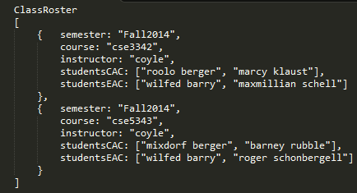
   2. 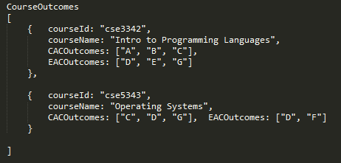
   3. 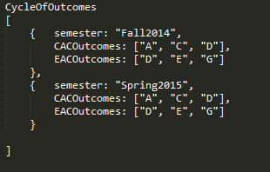
   4. 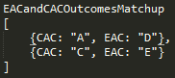
   5. Output: A PDF containing the Tabular data of the percentages of students that meet given outcomes.
2. Project Repo
   1. https://github.com/brannp66/SEP-ABET